Tolvaptan (JINARC®) RMP (RISK MANAGEMENT PLAN) PATIENT GUIDE

**Patients:** Your doctor will explain this patient guide to you. Ask questions if you have any. Keep this guide for important safety information about the serious risks of JINARC.

**Healthcare Providers:** Go over this patient guide with your patient, and give them a copy to take home.

WHAT IS JINARC®?

JINARC® is a prescription medicine used to slow kidney function decline in adults at risk of rapidly progressing autosomal dominant polycystic kidney disease (ADPKD). It is not known if JINARC is safe and effective in children.Top of Form

WHAT IS THE MOST SERIOUS RISK OF JINARC®?

JINARC® can cause serious liver problems that can lead to the need for a liver transplant or can lead to death

WHAT IS THE JINARC® RMP?

JINARC® RMP is a program required by Otsuka to manage the risk of serious and potentially fatal liver injury associated with JINARC® to make sure the benefits outweigh the risks. The program educates patients and healthcare providers about the risks of JINARC®. Requirements of the JINARC® RMP include the following:

1. Requires patients and healthcare providers to be enrolled and certified to receive and prescribe JINARC®.
2. Before and during treatment, your healthcare provider will check your liver function with blood tests.
3. JINARC® is only available through the JINARC® RMP.

**WHAT DO I NEED TO DO BEFORE I START TREATMENT WITH JINARC**®**?**

1. Receive and read the **Patient Guide**
2. Agree to have important blood tests before you start, and regularly while you are taking

JINARC - to monitor your liver health

1. Call the **JINARC Patient Support Team** to enroll in the JINARC® RMP

**WHO SHOULD NOT TAKE JINARC**®**?**

Do not take JINARC® if you:

* 1. have a history of **liver problems\***,
  2. cannot feel **thirst** or unable to **drink**
  3. have high or low **sodium** levels,
  4. are **dehydrated**,
  5. are **allergic** to Tolvaptan, or
  6. are unable to **urinate**.

**\****This excludes those with polycystic liver disease who have liver problems.*

**HOW WILL I RECEIVE JINARC**®**?**

1. Call the JINARC® Patient Support Team and share a copy of your Liver Function Test result and JINARC prescription to be enrolled.

2. After you are enrolled in the JINARC® RMP, you can now call the exclusive JINARC® distributor to order & fill your prescription.

• JINARC® is only available through the JINARC® RMP

• The JINARC® RMP will only dispense a one-month supply at a time

**WHAT DO I NEED TO DO BEFORE & WHILE I AM BEING TREATED WITH JINARC**®**?**

* 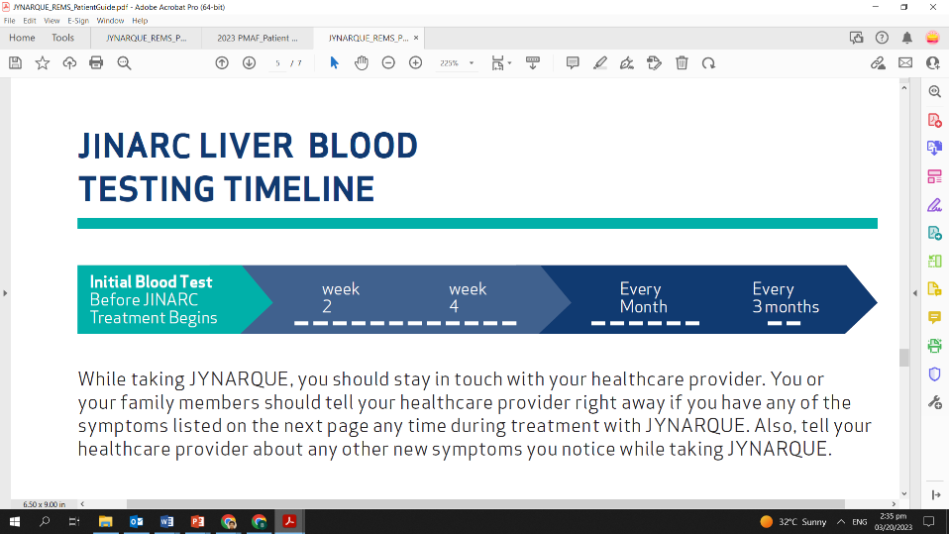Get a blood test:

— Before my treatment begins

— At 2 weeks after my treatment begins

— At 4 weeks after my treatment begins, and then

— Every month after that for the first 18 months, and

— Every 3 months from then on

* Contact your healthcare provider if you experience any side effects or symptoms after taking JINARC
* Inform the JINARC Patient Support Team if I change my healthcare provider, contact information, or stop taking JINARC.

**WHAT ARE THE SIGNS AND SYMPTOMS OF SERIOUS LIVER INJURY?**

You or your family member should contact your healthcare provider right away if you have any of

the following symptoms:

|  |  |
| --- | --- |
| — feeling tired | — fever |
| — loss of appetite | — rash |
| — nausea | — itching |
| — right upper stomach (abdomen) pain or tenderness | — yellowing of the skin and white part of the eye (jaundice) |
| — vomiting | — dark urine |



# Otsuka (Philippines) Pharmaceutical, Inc.

Manufactured by Otsuka Pharmaceutical Co., Ltd., Tokyo, 101-8535 Japan.

Distributed and marketed by Otsuka (Philippines) Pharmaceutical, Inc., Makati, Philippines.

JINARC is a registered trademark of Otsuka Pharmaceutical Co., Ltd., Tokyo, 101-8535 Japan.

©2023 Otsuka (Philippines) Pharmaceutical, Inc. March 2023 Promo Mat. Code